**CREATE IBM WATSON IoT PLATFORM AND A DEVICE**

|  |  |
| --- | --- |
| Date | 5 November 2022 |
| Team ID | PNT2022TMID04642 |
| Project Name | Smart Farmer-IoT Enabled Smart Farming Application |

CREATING IBM WATSON IoT PLATFORM

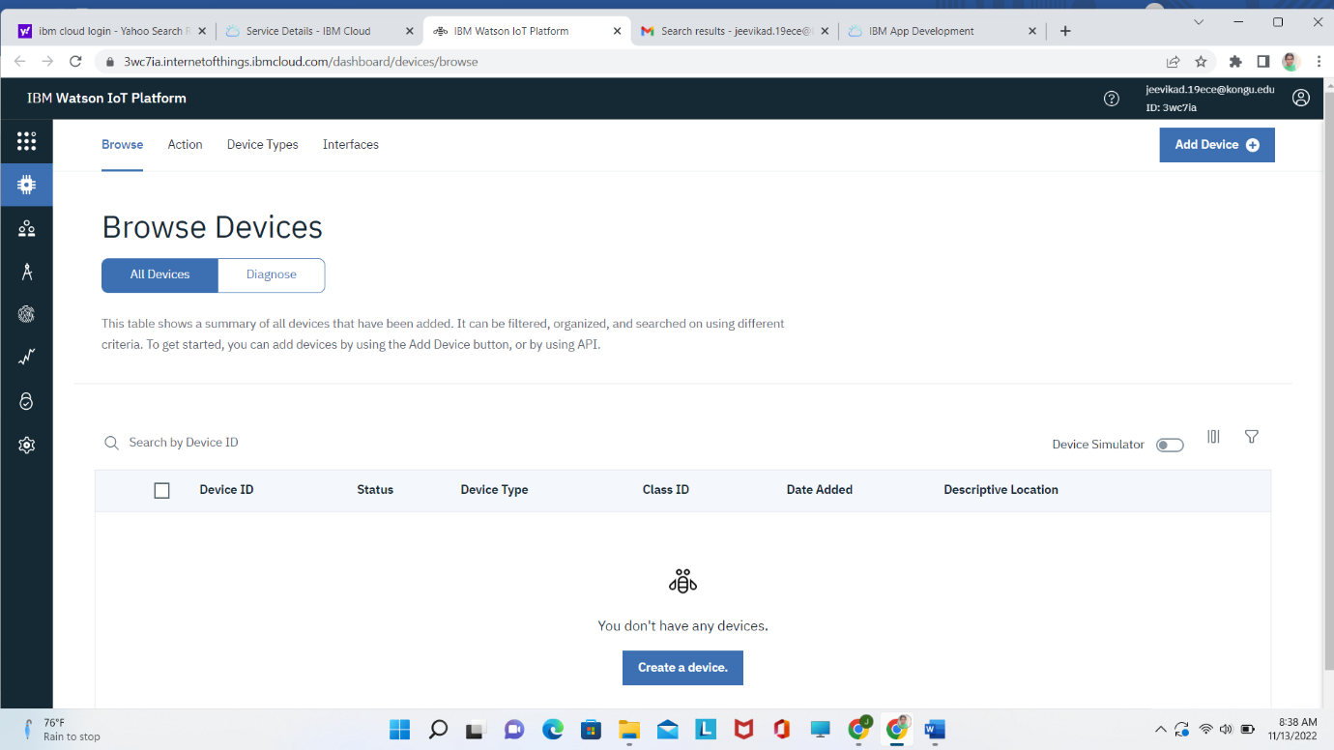

CREATING A DEVICE ON IOT

